**WinSCP file transfer between Raspberry Pi and windows**

We need to transfer files between Windows and Raspberry Pi two different systems. Since this is two different file systems, we need to use the SSH service to transfer files across systems.

**1.Install WinSCP**

WinSCP official website：<https://winscp.net/eng/download.php>

**(This software in the Tool folder.)**

**1564711717364005.png**

Double-click to open the program and start the installation, click “Accept” to accept the agreement, and then follow the prompts to install.

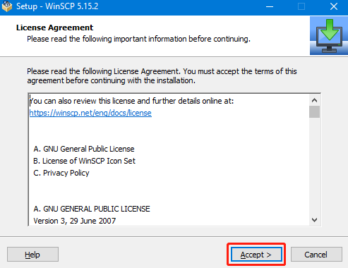

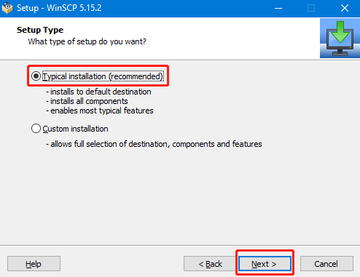

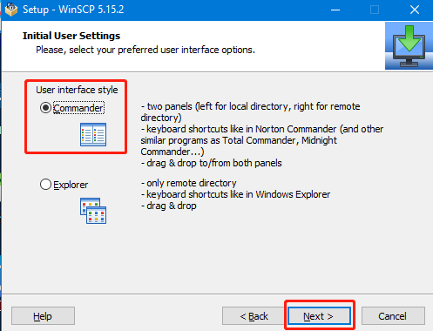

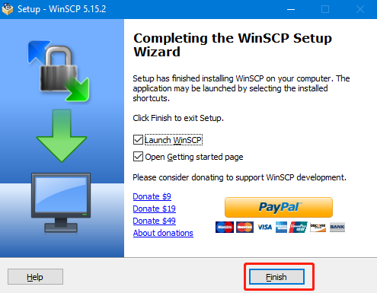

After install is complete, we can see that a WinSCP shortcut on the desk .

**2. Transfer file**

The following login screen will appear after opening the WinSCP software.File protocol：choose SFTP，

Host name：IP Address of your Raspberry Pi，

Port number：22 (default),

User name：pi,

Password：(your password).

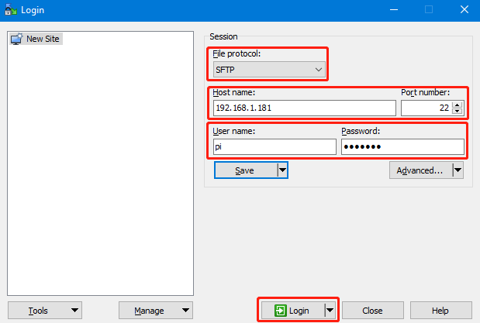

 Then, we need to click 【Login】.

After the login is successful, the following interface will be displayed. On the left is the folder of the windows computer system, and on the right is the folder of the Raspberry Pi system.

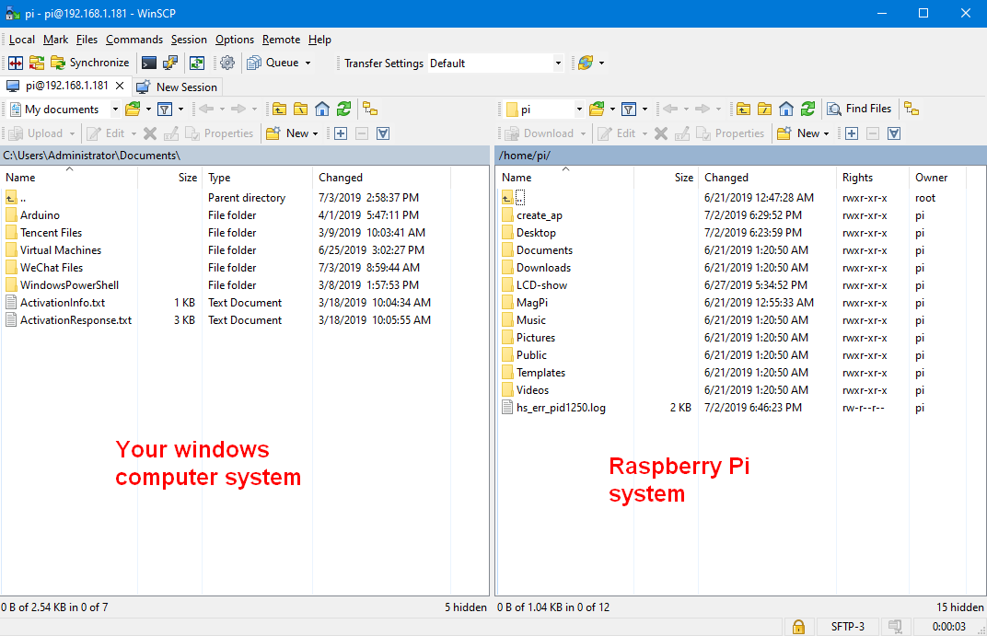

**File transfer has three modes of operation：**

1. The first is to drag the file directly from the left to the right, or from the right to the left, the system will automatically copy a file transfer.

2. Clicking on a file with mouse and then press the F5 on the keyboard, this file will copy to the other side.

3. Select the file and click the right button of mouse.

If the file is transferred from the windows computer system to the Raspberry Pi system, you need to click **Upload**. As shown in Figure 1 below. If the file is transferred from the Raspberry Pi system to the windows computer system, you need to click **Download**. As shown in Figure 2 below.

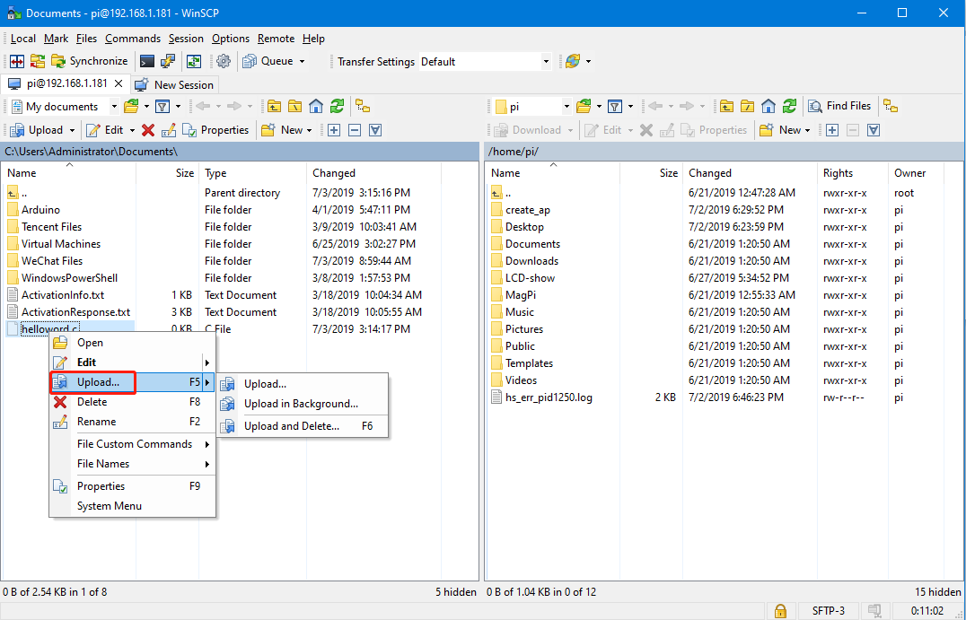

Figure 1

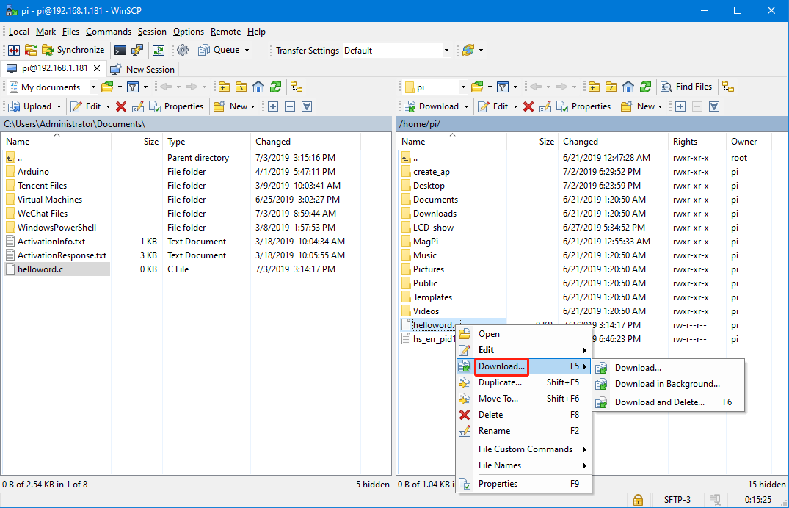

Figure 2

If the system displays the prompt as shown below, you can choose **“Do not to show this dialog box again”** and click OK, the file is automatically transferred.

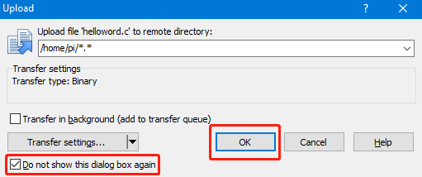

**!!!Note: File transfer requires the computer and the Raspberry Pi to be on the same LAN, and the Raspberry Pi has the SSH service enabled.**

**If the failure to the transfer file is generally not enough permissions on the Raspberry Pi side, we only need to give the highest authority.**

**We can enter the command as shown below to give the file the highest permission.**

**chmod 777 Raspberry Pi directory name**

Eg: chmod 777 helloword.c